Too Much Is Never Enough

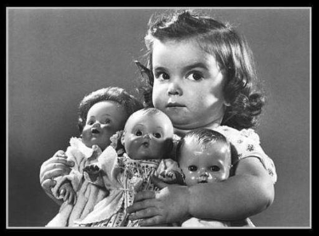

#1
Why I Am Leaving Goldman Sachs, by Greg Smith, Op-Ed Contributor, New York Times
And I can honestly say that the environment now is as toxic and destructive as I have ever seen it. … To put the problem in the simplest terms, the interests of the client continue to be sidelined in the way the firm operates and thinks about making money.
… My clients have a total asset base of more than a trillion dollars. I have always taken a lot of pride in advising my clients to do what I believe is right for them, even if it means less money for the firm. This view is becoming increasingly unpopular at Goldman Sachs. Another sign that it was time to leave...

Question: If you were in Greg Smith’s position, would you quit for his reason?

#2
Wealth of Nations, Adam Smith, 1776
It is not from the benevolence of the butcher, the brewer, or the baker that we expect our dinner, but from their regard to their own interest. We address ourselves, not to their humanity but to their self-love, and never talk to them of our own necessities but of their advantages.

Wall Street (American drama film, 1987)
Gordon Gekko: “Greed is good. Greed is right. Greed works. Greed… has marked the upward surge of mankind.”

Questions:
(a) Is modern economy based on greed?
(b) Is there a difference between self-interest and greed?
(c) Where is the line between ambition and greed?
(d) ) What is the source of greed?

#3
Rabbi Lazer Brody
There are different types of misers:
1. Some misers are stingy with strangers, but not with their families.
2. … generous in public, and stingy with their families.
3. … stingy with everyone. They are stingy with strangers and with family, but generous with themselves…
4. … stingy with everyone. They don't even allow themselves to enjoy their own money.

Questions:
How do you explain the four types of misers?

#4
Even Shlema, The Vilna Gaon
All sins come from greed as it says: “Do not covet.” And the last of the 10 commandments includes in it all the 10 commandments, which themselves include the entire Torah.

(I.e. the ten commandments include the entire Torah and the last of the ten commandments, includes all the 10, therefore the 10th commandment “Do not covet” summarizes the whole Torah).

Shaarei Kedusha (The Gates of Holiness), Rabbi Chaim Vital (2:4)
Greed […] brings to hatred, theft, false oaths, murder ...

Question: How can greed be the source of all evil?

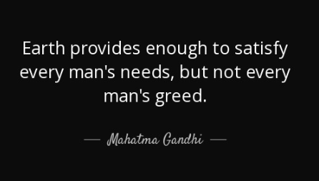

#5
Talmud Makos 10a
‘He who loves money will not be satisfied with [any amount of] money’ (Koheles 5:9).
This refers to Moshe who knew that the cities of refuge (for those who accidentally murder a fellow Jew) he separated would not be used until after his death, when the Jews conquered the land of Israel (and dedicated an additional three cities in the mainland as cities of refuge).
In any case he seized the opportunity to do the Mitzvah.

Question: What are positive aspects to greed?

#6

Stereotypes of Jews, Wikipedia
Jews have often been stereotyped as greedy and miserly...
… A telephone poll of 1747 American adults conducted by the Anti-Defamation League in 2009 found that 18% believed that “Jews have too much power in the business world", 13% that “Jews are more willing than others to use shady practices to get what they want”, and 12% that “Jews are not just as honest as other businesspeople.”

Question: What do you think about these accusations?

American Jews and charitable giving: An enduring tradition, theconversation.com/american-jews-and-charitable-giving-an-enduring-tradition-87993
Even though only about one in 50 Americans is Jewish, U.S. Jews donate at high levels, both as individuals and as a community. As a scholar who studies community philanthropy, I am doing research to discover what accounts for this outsized generosity and why Jews play such a big role in American philanthropy ...

Talmud Yevamos 79b
There are three signs of members of the Jewish People: they are merciful, bashful, and doers of acts of kindness.

#7
Mishnah Pirkei Avos 5:13
There are four character types among people: a) One who says, “Mine is mine, and yours is yours,” is an average character type, but some say this is characteristic of Sodom (The residents of Sodom epitomized selfishness); b) Mine is yours, and yours is mine,” is an unlearned person; c) ”Mine is yours, and yours is yours,” is scrupulously pious; d) “Yours is mine, and mine is mine,” is wicked.

Mishnah Pirkei Avos 4:28
Jealousy, lust, and glory remove a person from the world.
Rashi ibid.
Lust. Refers to lust for money ...

Iggeres HaGra, The Vilna Gaon
Indulging one’s lust is compared to drinking salty water; the more you drink, the thirstier you get.

Question: What’s the possible cure from greed?

#8
Question: What’s your takeaway from today’s discussion?

